JAMES WISDOM OZMENT

THE MAN WHO ELECTRIFIED PALESTINE

TO THE PROFESSIONAL HISTORIAN, HISTORY IS THE RECORD OF IMPORTANT EVENTS – the ACHIEVEMENTS AND DEEDS OF GREAT MEN AND WOMEN – WARS AND EMPIRES, MONARCHIES AND CHURCHES, STRUGGLES AND CONQUESTS.

HOWEVER, TO MOST OF THE REST OF US, HISTORY IS EVERYTHING that HAPPENED IN THE PAST – PARTICULARLY TO OUR FAMILIES AND OUR COMMUNITIES. THUS, WHAT OUR grandparents or GREAT GRANDPARENTS experienced AND ACCOMPLISHED MAY BE MORE IMPORTANT TO US THAN THE national and INTERNATIONAL EVENTS THAT SWIRLED AROUND THEM and CERTAINLY AFFECTED THEIR LIVES.

ON A LOCAL LEVEL AND FROM the VANTAGE POINT OF A much LATER BACKWARD GLANCE, WE OFTEN REMEMBER THOSE WHOSE ACTIONS AFFECTED THE LIVES OF OUR FOREBEARS PRIMARILY THROUGH LANDMARKS – STREETS OR PARKS OR SCHOOLS NAMED FOR THEM, HISTORICAL MARKERS ATTESTING TO THEIR CONTRIBUTIONS, OTHER TANGIBLE SIGNS.

even so, THOSE WHO HAVE NO SUCH PRESENT-DAY PUBLIC ACCOLADES ARE OFTEN THE ONES WHO MADE THE GREATEST CONTRIBUTIONS – THEY SIMPLY MAY NOT HAVE THE BEST “SPIN DOCTORS” TO recount THEIR deeds in THE PRESENT DAY.

IN THE CASE OF our city, THE BEST SUCH EXAMPLE IS JAMES WISDOM OZMENT – THE MAN WHO ELECTRIFIED PALESTINE. A PHOTOGRAPH FROM MARCH 1917:
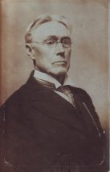
THE GROWTH AND PROGRESS OF palestine WAS HIS PRIMARY AMBITION IN LIFE. pauline hohes in her centennial history of anderson county stateD it pretty well: “he saw every opening and was quick to seize every opportunity to promote the progress of his home town.”

TODAY, THERE IS ALMOST NOTHING THAT MARKS HIS HALF CENTURY LIFE IN PALESTINE AND ALL THAT HE DID FOR THE TOWN, THOUGH AT ONE TIME, IT WAS COMMON TO HEAR PEOPLE REMARK, WHEN SPEAKING OF SOME DEVELOPEMNT IN TOWN THAT “PALESTINE OWES THAT TO J. W. OZMENT” OR “I REMEMBER WHEN MR. OZMENT PUT THAT OVER.” WERE IT NOT FOR HIS FEW SURVIVING DESCENDANTS HERE IT WOULD appear THAT HE HAS NO LEGACY WHATSOEVER.

OZMENT WAS BORN IN 1842 in TN, THE Son of Varnum Ozment and Harriet Kincard. Varnum Ozment operated the old Farmer’s Inn, a noted tavern in Memphis, Tennessee. In 1849, HE moved to Rusk in Cherokee County, with his son J. W. WHERE He operated the Cherokee Hotel. here is an advertisement for that hotel in 1856.
JWO WORKED AS a Clerk in his father’s hotel UNTIL 1860 WHEN HE left Rusk to enroll in Dolbach College in New Orleans. In 1862, he left school and enlisted in the Confederate Army, ServING until THE end of War, WHEN he moved to Palestine.

SEEMS LIKELY THAT HE MOVED HERE BECAUSE OF HIS RELATIONSHIP WITH cHARLES STERNE AND THE MALLARD FAMILY. AFTER MOVING TO RUSK, VARNUM OZMENT, A WIDOWER, HAD MARRIED A DAUGHTER OF COL. eldridge MALLARD. ANOTHER DAUGHTER HAD MARRIED CHARLES STERNE – THUS STERNE WAS OZMENT’S UNCLE BY MARRIAGE.

AFTER MOVING TO PALESTINE, in 1867 HE MARRIED EVA L. MARTIN, DAUGHTER OF JOHN AND LUCINDA MARTIN. THE MARTINS WERE PIONEER ANDERSON COUNTY SETTLERS, AND EVA HAD GROWN UP IN AND WITH PALESTINE. Here is her photograph circa 1880.
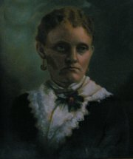
THAT SAME YEAR HE BOUGHT HIS FIRST STORE, A MERCANTILE ESTABLISHMENT ON THE NORTH SIDE OF THE COURTHOUSE SQUARE NEXT TO THE LAW OFFICE OF JAMES PERRY. IN 1871, HE ADDED ANOTHER STORE – A GROCERY STORE IN MOUND PRAIRIE. THE BUSINESS SOON TURNED EXCLUSIVELY TO HARDWARE UNDER THE NAME J. M. SILLIMAN & CO – AND HE ULTIMATELY SOLD OUT TO SILLIMAN IN 1889.

MERCANTILISM DID NOT LONG HOLD OZMENT’S INTEREST – HE WAS PRINCIPALLY AN ENTREPENEUR AND CAPITALIST AND HIS INTERESTS SOON TURNED IN that DIRECTION. HIS INVESTMENT ACTIVITIES FOCUSED ON THREE AREAS: FINANCE, PUBLIC UTILITIES AND RAILROADS/OIL & GAS.

FROM THE STANDPOINT OF THE DEVELOPMENT OF PALESTINE, HIS INVOLVEMENT IN FINANCE AND PUBLIC UTILITIES WAS THE MOST IMPORTANT – though not his only contribution to the city.
In 1871 he was among a group of businessmen who bought land and gave it to the I&GN RR to induce them to run their line to palestine. WHEN PALESTINE WAS INCORPORATED IN 1872 HE WAS ONE OF THE ORGANIZING ALDERMEN, AND HELPED CHARTER THE PALESTINE FIRE COMPANY IN 1873, SERVING AS ONE OF THE FIRST FIRE CHIEFS IN THE CITY. iN HIS LATER YEARS, HE WAS THE PRINCIPAL ORGANIZER OF THE BOARD OF TRADE AND THE BUSINESS MEN’S LEAGUE, FORERUNNER OF the CHAMBER OF COMMERCE.

ozment REALIZED THAT FOR PALESTINE TO GROW THERE HAD TO BE SOME WAY FOR ordinary PEOPLE TO BUY HOMES IN THE NEW CITY. BETWEEN 1874 AND 1891 HE ORGANIZED THREE LOAN AND REAL ESTATE COMPANIES, INCLUDING ONE OF the FIRST BUILDING AND LOAN ASSOCIATIONS IN THE STATE, AND in 1891 HIS VARIOUS COMPANIES WERE PUTTING $7,000 EACH MONTH INTO PALESTINE HOMES.

palestine was not all business, however. each year there was a huge 4th of july celebration. in 1882 that celebration was marked by a contest to choose the homeliest man in palestine – must have been something like a roast at the friar’s club today – when all the votes were tallied the winners, in a tie, were j. w. ozment and a. w. gregg. after looking at ozment’s photo from that era, i have to wonder what the others looked like.
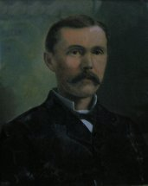

ozment was clearly a visionary. on a trip to DALLAS, he witnessed electric lighting, PROBABLY AT THE DOWNTOWN BUSINESS HOUSE OF JOHN HEARNE – the first in dallas with electric lights. he and hearne were close friends and business associates.

thomas edision did not invent the light bulb – contrary to popular lore. he perfected the filament and thereby created a practical, workable light bulb. Edison himself established the edison Illuminating Company in 1880 to construct electrical generating stations, initially in NYC. it became the prototype for other local illuminating companies established in the US during the 1880’s.

ozment immediately recognized ELECTRICITY’S potential to revolutionize life. he returned to palestine and convinced skeptical associates that electric lighting could be sold to the public to light homes as well as businesses, and thus was born the first domestic lighting plant in texas. in 1885, ozment organized the edison illuminating company of palestine for that very purpose.

IN january 1886, ozment and J. H. bryan SOLD THE PROPERTY AT #112 combination street, LATER GOOCH STREET, to the EIC of P, Texas. the first light plant was built there, between sycamore and magnolia. in fact, at that same time, south sycamore was cohen street.

by mid march THERE WAS MUCH EXCITEMENT IN THE AIR – IN FACT IT WAS ELECTRIC WITH EXCITEMENT ABOUT THE OPENING OF THE LIGHT PLANT. A LARGE GROUP GATHERED IN AND AROUND THE RAILROAD DEPOT TO SEE THE FIRST ELECTRIC LIGHTS GO ON, TO BEGIN REGULAR SERVICE FOR PALESTINE. DURING THE CELEBRATION, THE ELECTRIC GLOBE BURNED OUT, LEAVING ALL IN DARKNESS. MANY ON-LOOKERS WERE FRIGHTENED, AND, ALREADY SKEPTICAL ABOUT ELECTRICTY, CLIMBED OUT WINDOWS AND DOORS SEEKING THE QUICKEST EXIT.

BY 26 MARCH 1886, IT WAS Reported that the Edison system of incandescent electric lighting from a central station had been in practical operation for several nights and WAS working satisfactorily. Most places of business on the line (Spring and Main Streets and Avenue A) WERE illuminated with glittering bulbs THAT emitTED a soft, steady light. The electric circuit of main and feeders extendED over 6000 feet from the company’s works.

BY SEPTEMBER 1, IT WAS Reported that Palestine streets were lighted by electricity; that the Edison Illuminating Company had erected a central station and put in a plant for lighting the streets, stores and residences with incandescent lights, haD over 300 lights going, operated by the 3-wire, double dynamo system. however, some accounts note that BREAKDOWNS in service, with a day or two of no electricity at all, were accepted as unavoidable.

The cost was $1.00 per drop per month. A “drop” was a carbon lamp swung from the ceiling by a light cord, as wall switches were then unknown.

The light plant began operating about dark and closed down around the time they felt everyone should be in bed. Electrical service available only for two hours in the evening at first. No electrical appliances, used only for lighting. Later when the electric iron was invented (1892) it was customary for the company to turn the electricity on at certain times during the day when people were doing their ironing.

During the DAY, the machinery was repaired and maintained to have it in working order by night. On OCCASION, the lights were turned off for several days if the machinery was not working – accepted cheerfully. A FAVORITE pastime WAS to go down to the plant and watch the big dynamo wheel turn. If the large belt on the wheel slipped, the lights dimmed all over town.

THAT LOCATION WAS NOT SATISFACTORY. BY MAY 1887, OZMENT HAD MOVED THE LIGHT PLANT TO THE BUILDING THAT HAD HOUSED THE OLD SKATING RINK, AT 304 EAST CRAWFORD, A LOCATION BEHIND THE AVENUE BAPTIST CHURCH AND NEAR THE EURKEA COTTON GIN MANUFACTURING COMPANY – ANOTHER OF OZMENT’S ENTERPRISES.
NOTICE ON THIS PLAT THE LOCATION OF THE Christian Church, said to have been the first church in Texas to have electricity.

IT SEEMS TO BE a RELATIVELY COMMON SITUATION THAT EARLY VISIONARIES HAVE ALWAYS HAD PROBLEMS GETTING THEIR IDEAS OFF the GROUND. SUCH WAS the CASE WITH OZMENT’S COMPANY. PEOPLE WERE SLOW TO ACCEPT THE NEW FANGLED INVENTION. IT WAS NOT UNTIL THE LATE 1890’S THAT THE COURTHOUSE HAD ELECTRIC LIGHTS. BY DECEMBER 1898, THERE WERE 10 LIGHTS IN THE DISTRICT COURTROOM AND PLANS WERE in the WORKS TO PUT LIGHTS IN THE TAX COLLECTOR’S OFFICE AND IN THE HALLWAYS, then SOME LIGHTING FOR THE COUNTY TREASURER’S OFFICE. THE NEWSPAPER REPORTED THAT THE “COURTHOUSE WOULD BE LIKE A CITY WHOSE LIGHT CANNOT BE HIDDEN.” mAYBE THE COUNTY FATHERS DID NOT BUY INTO THE IDEA OF ELECTRICITY EARLIER SINCE LADY JUSTICE WAS SUPPOSEDLY BLIND AND LIGHTING WOULD MAKE NO DIFFERENCE – MORE THAN LIKELY IT WAS A MATTER OF NOT WANTING TO SPEND THE MONEY.

WHATEVER THE CAUSE, EARLY IN 1895, THE light company WENT INTO RECEIVERSHIP AND ALL ITS PROPERTY WAS SOLD TO JOHN HEARNE. news reports from the dmn indicated that THE COMPANY HAD SERIOUS INDEBTEDNESS AND STATED THAT IT WAS THE FIRST INCANDESCENT ELECTRIC LIGHT PLANT IN TEXAS.

in FEBRUARY 1895 THE PALESTINE ELECTRIC LIGHT COMPANY OF PALESTINE, TEXAS WAS INCORPORATED BY JOHN HEARNE and others and HEARNE IMMEDIATELY TRANSFERRED ALL THE ASSETS THAT HE HAD BOUGHT AT THE RECEIVER’S SALE TO THE NEW COMPANY AND BUSINESS CONTINUED. MAYBE IT WAS AN EARLY DAY STRUCTURED BANKRUPTCY LIKE GM IS CONTEMPLATING – BUT WITHOUT ANY FEDERAL BAILOUT MONEY.

tHE LIGHT PLANT CONTINUED IN ITS SAME LOCATION ON CRAWFORD STREET. bY 1905 THERE WERE two FULL TIME EMPLOYEES OPERATING IT. EVEN UNDER THE NEW OWNERSHIP THE BUSINESS HAD FINANCIAL PROBLEMS, AND WAS FINALLY SOLD TO TEXAS UTILITIES (LATER TP&L) IN 1912.

OZMENT WAS NOT ONE TO DO ONE THING AT A TIME. after selling his harwarde business in 1889, with OTHER INVESTORS he ORGANIZEd PALESTINE’S 2ND BANK – THE PALESTINE NATIONAL BANK. OTHER DIRECTORS WERE JOHN HEARNE, GEORGE DILLEY, W. P. SAVAGE, W. C. GORMAN AND B. F. BROYLES. OZMENT WAS PRESIDENT. OZMENT SOLD HIS INTEREST IN THAT BANK TO THOMAS M. CAMPBELL, WHO LATER SOLD IT, IN 1906, TO A. L. BOWERS. IT MERGED WITH THE ROYALL NATIONAL BANK IN 1913. even with the bank having such a short life, j. e. angly and cad e. williams – tWO OF PALESTINE’S BANKING GIANTS – had early careers there.

ozment realized that a town needed public utilities to grow. by february 1890, he had become manager of the palestine water company, brought in to clean up its troubled operations. after a dispute with the city council during which he shut off the water supply to make his point he was able to put the system on a paying basis.

OZMENT’S INFATUATION WITH TECHNOLOGY DID NOT STOP WITH ELECTRICITY. about 1900 he purchased the palestine telephone company. the first telephone system had been installed in palestine about 1882, but the system was poorly managed, and inadequate for the needs of a growing town.

ozment immediately reorganized the company and put it on a paying basis. it had 90 subscribers when he bought in, but by 1906 he had 850 subscribers – having spent over $20,000 in improvements to the system. the telephone exchange was located on the second story of the building that later housed pryor’s men’ store, next to little bratton’s.

NEVERTHELESS, the telephone was still a novelty to many. ozment reported to the local newspaper on 14 may 1908 that it was just a mistake to think that women were afraid to use the telephone during storms. on the previous day – presumably a stormy day – for 4 hours he had never seen such a run on the local exchange with women on the telephone. it required 12 – 14 people just to keep up. MOREOVER, OF COURSE, HE WAS TALKING ABOUT WOMEN – WITHOUT WHOM THERE WOULD HAVE BEEN NO TELEPHONE EXCHANGE.

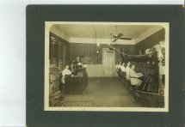
telephone operating room circa 1915
OZMENT CONTINUED TO OWN AND OPERATE THE TELEPHONE COMPANY UNTIL HIS DEATH.

even with all the businesses, investments and activities discussed already we have only scratched the surface of ozment’s activities – time will not permit a discussion of his extensive involvement with railroads – he drove the last spike in the state railroad connecting palestine with rusk on 23 july 1909 – or his oil and gas interests – or his extensive insurance agency opened about 1868 – his only business that still has a local presence after several transfers of ownership as the kenderdine insurance agency.

not to be forgotten are ozment’s family and personal activities. he and his wife had five daughters: Jewel, pearl, ruby, coral and garnet. pearl married robert jenkins and their descendants, phil and steve jenkins and their sister linda swinney live in palestine. none of the other daughters had any children. ozment was a methodist, a mason, a member of the knights of honor, knights of pythias.

ozment and his wife bought the albert joost house on n. link street in 1910 and he lived there for the remainder of his life.
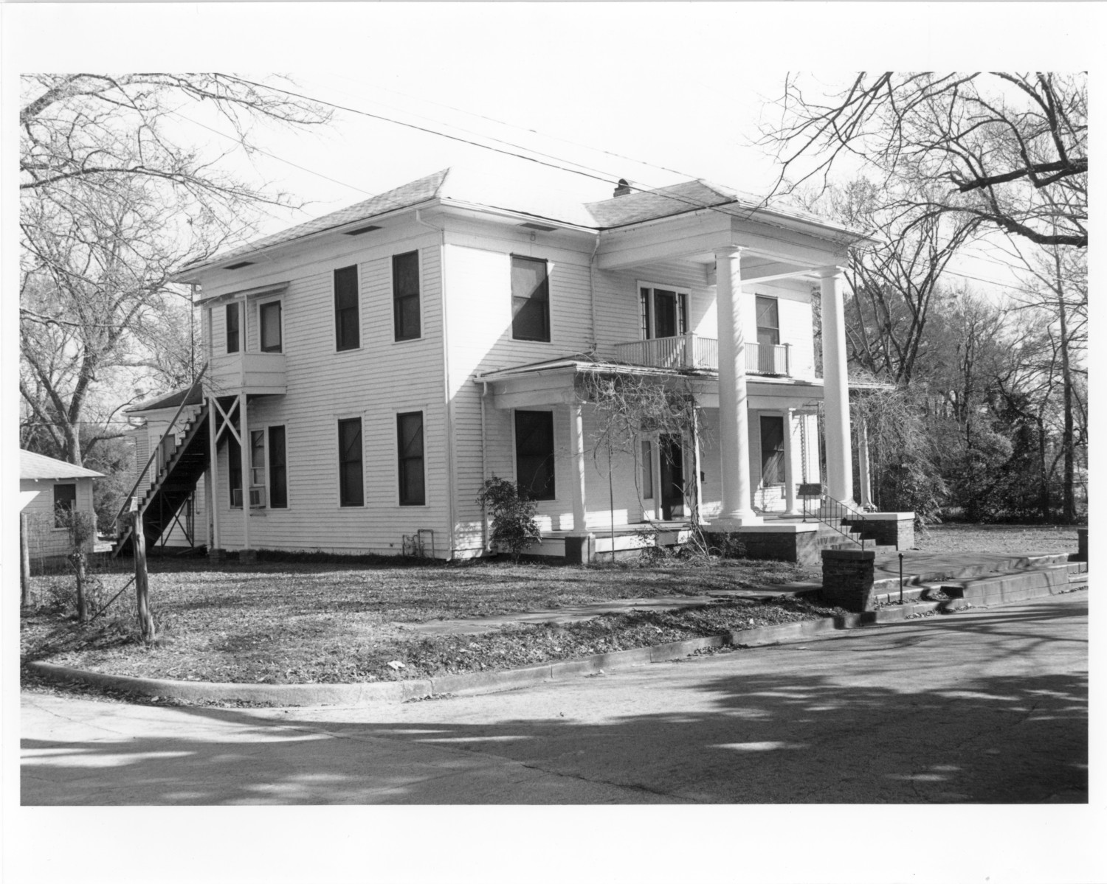
he became ill while on a business trip to dallas in 1918. after returning HOME, he was taken to john sealy hospital in galveston where he died on march 26. he IS BURIED in east hill cemetery.

the best summary of his LIFE and his dedication to the improvement of this city is probably found in his obituary in the palestine herald where he was referred to as a most useful citizen, a man of exceptional energy who devoted much of his time to the good of his community.

a 1906 dmn article reported a conversation between governor campbell and ozment that pretty well tells all we need to know about ozment. OZMENT TOLD CAMPBELL THAT HE HAD JUST CLOSED A CONTRACT FOR IMPROVEMENTS TO THE TELEPHONE EXCHANGE. LISTEN TO THEIR CONVERSATION: “WHY DON’T YOU QUIT MAKING IMPROVEMENTS AND TAKE SOME PROFITS OUT OF THE BUSINESS?” CAMPBELL ASKED. OZMENT’S RESPONSE: “OH, WE’RE GETTING BREAD AND MEAT OUT OF IT. DO YOU GET ANY MORE? wE CAN’t STOP MAKING IMPROVEMENTS … THIS BUSINESS IS GROWING SO THAT WE ARE JUST FORCED TO PUT IN A CENTRAL ENERGY PLANT.”

OZMENT WAS ALWAYS BUILDING FOR THE FUTURE AND WHAT LAY AHEAD RATHER THAN LINING HIS OWN POCKETS IN THE SHORT TERM. WE CAN ONLY IMAGINE HOW MUCH BETTER OUR COUNTRY’S ECONOMY WOULD BE IF BUSINESS LEADERS now HAD THAT SAME PHILOSPHY.

TODAY, AS WE REFLECT ON SOME OF HIS many life-changing CONSTRIBUTIONS TO THIS TOWN, OUR COLLECTIVE MEMORY OF all that he did FOR PALESTINE will surely be A SUFFICIENT LEGACY.

